**ABSTRACT**

"Heal Naturally" is an innovative project centered around harnessing the power of yoga to promote holistic health and wellness. Developed using advanced Java technologies, this project offers a comprehensive platform that integrates yoga practices with modern health management techniques. Through a user-friendly interface, individuals can access a wide range of yoga routines tailored to address specific health concerns, such as stress, anxiety, chronic pain, and flexibility.

The platform utilizes advanced algorithms to personalize recommendations based on user preferences, fitness levels, and medical history, ensuring a safe and effective yoga experience for all users. Additionally, "Heal Naturally" incorporates features for goal setting, fostering motivation .

By leveraging the principles of yoga and cutting-edge Java programming, this project aims to empower individuals to take control of their health journey and achieve lasting well-being naturally.

**INDEX**

|  |  |  |
| --- | --- | --- |
| **Sr. No** | **Topic** | **Page No** |
| **1** | **Introduction**   * Benefits of Yoga for Health * Overview | **1** |
| **2** | **Literature Review of Topic** | **4** |
| **3** | **System Analysis**   * Understanding Requirements * Functional Requirements * Non-Functional Requirements * Feasibility Study * Technical Feasibility * Economic Feasibility * Operational Feasibility * Scheduling Feasibility * Software Process Model * Data Flow Diagram(DFD) * 0th Level DFD * 1st Level DFD * 2nd Level DFD * Entity Relationship Diagram(ERD) * Flow Chart | **5** |
| **4** | **System Design**   * Input to the Project * Output to the Project * Modularization Details * User Interface Module * Yoga Routine Module * Management Module * User Authentication and Authorization Module * Data Management Module * Integration Module * Administrative Model * Class Diagram * Process Logic * Data Integrity * Data Dictionary | **18** |
| **5** | **Tools and Environment** | **29** |
| **6** | **Software Description**   * Textpad * Java | **30** |
| **7** | **ProjectUI** | **31** |
| **8** | **Testing**   * Use Case | **38** |
| **9** | **Implementation** | **42** |
| **10** | **Future Scope** | **43** |
| **11** | **Conclusion**   * Key highlights of the project | **45** |
| **12** | **References** | **47** |

**HEAL N****ATURALLY**

**INTRODUCTION**

Are you ready to embark on a transformative journey of healing and well-being? Look no further! Our website is your ultimate destination for all things yoga and holistic wellness.

At "Heal Naturally ," we believe in the incredible power of yoga to heal the mind, body, and soul. Whether you're a seasoned yogi or a curious beginner, our goal is to provide you with the tools, knowledge, and inspiration to enhance your well-being through the practice of yoga.Through our carefully curated articles and resources, you'll discover a wealth of information on various yoga styles, poses, and breathing techniques. We'll guide you on how to incorporate yoga into your daily life, helping you find balance, reduce stress, and cultivate inner peace and solve your health problems.

But "Heal Naturally” is more than just a website. It's a community of like-minded individuals who share a passion for holistic health and wellness. Join our vibrant community, connect with fellow yogis, and share your experiences and insights. Together, we'll support and uplift each other on our yoga journeys.

So, whether you're seeking physical healing, emotional well-being, or simply a deeper connection with yourself, "Heal with Yoga" is here to guide you every step of the way. Get ready to unlock your full potential and embrace a life of vitality, joy, and harmony. 🌈😊

**1**

**BENEFITS OF YOGA FOR HEALTH**

Yoga offers numerous benefits for health! Here are some key benefits:

**1. Physical fitness:** Yoga helps improve flexibility, strength, and balance. It enhances muscle tone, promotes better posture, and increases overall physical fitness.

**2. Stress reduction:** Engaging in yoga practices such as deep breathing, meditation, and relaxation techniques can help reduce stress levels and promote a sense of calm and relaxation.

**3. Mental well-being:** Yoga is known to improve mental health by reducing anxiety, depression, and improving overall mood. It can also enhance mental clarity, focus, and promote a positive mindset.

**4. Improved sleep:** Regular yoga practice can help improve the quality of sleep by promoting relaxation and reducing stress. It can also help with insomnia and other sleep-related issues.

**5. Increased energy and vitality:** Yoga practices, such as dynamic poses and breathwork, can help boost energy levels, improve circulation, and enhance overall vitality.

**6. Enhanced flexibility and mobility:** Yoga poses and stretches help improve flexibility, increase joint mobility, and reduce the risk of injuries. It can also help alleviate muscle tension and stiffness.

**7. Better respiratory health:** Yoga incorporates deep breathing techniques that enhance lung capacity, improve respiratory function, and promote overall respiratory health.

**2**

**8. Heart health:** Certain yoga practices, such as gentle flows and relaxation techniques, can help lower blood pressure, reduce the risk of heart disease, and improve cardiovascular health.

**OVERVIEW**

The objective of the "Heal Naturally" project is to provide a user-friendly platform that utilizes advanced Java technologies to promote holistic health and wellness through yoga. This platform aims to:

1. Offer personalized yoga routines tailored to address specific health concerns.

2. Incorporate advanced algorithms to customize recommendations based on user preferences, fitness levels, and medical history.

3. Provide features for progress tracking, goal setting, and community support to enhance motivation and accountability.

4. Empower individuals to take control of their health journey and achieve lasting well-being naturally through the practice of yoga.

**3**

**LITERATURE REVIEW**

Yoga has gained significant attention in recent years as a holistic approach to improving physical and mental health. Numerous studies have explored the effects of yoga on various aspects of well-being, including stress reduction, flexibility, strength, and overall quality of life.

In a meta-analysis conducted by Smith et al. (2019), findings revealed that regular yoga practice was associated with reductions in perceived stress levels and improvements in overall mental health. Additionally, a review by Cramer et al. (2020) highlighted the positive impact of yoga on physical health outcomes, such as increased flexibility, muscle strength, and balance.

Furthermore, research conducted by Khalsa et al. (2016) indicated that yoga interventions can be effective in managing chronic conditions, such as hypertension and diabetes, by promoting relaxation responses and improving cardiovascular health. Similarly, a study by Sharma et al. (2018) demonstrated the efficacy of yoga in reducing symptoms of anxiety and depression, suggesting its potential as a complementary therapy for mental health disorders.

Moreover, studies have shown that yoga interventions can enhance mindfulness and self-awareness, leading to greater emotional regulation and resilience (Gard et al., 2014; Birdee et al., 2016). This aspect of yoga aligns with its holistic philosophy, emphasizing the integration of mind, body, and spirit to promote overall well-being.

This literature review provides a summary of key findings from various studies on the benefits of yoga, contextualizing the relevance of the Heal with Yoga website in promoting health and well-being through yoga practice.

**4**

**SYSTEM ANALYSIS**

System analysis is a crucial phase in the development of any software project, including "Heal Naturally." It involves a comprehensive study of the existing system, its functionalities, and the requirements of the proposed system. Here's a detailed breakdown of system analysis:

**UNDERSTANDING REQUIREMENTS**

The first step is to gather requirements from stakeholders, including users, developers, and domain experts. This involves conducting interviews, surveys, and workshops to elicit functional and non-functional requirements. For "Heal Naturally," this would include understanding the desired features, user preferences, target audience, and technical constraints.

**FEASIBILITY STUDY**

Once the requirements are gathered, a feasibility study is conducted to assess the viability of the project. This involves analyzing technical, economic, and operational aspects to determine whether the project is feasible within the given constraints. For "Heal Naturally," feasibility would be evaluated in terms of technical capabilities, resource availability, market demand, and potential return on investment.

**SYSTEM MODELING**

System analysts create various models to represent the system from different perspectives. This includes:

**5**

* **Use Case Diagrams:** Describing the interactions between users and the system.
* **Activity Diagrams:** Illustrating the flow of activities within the system.
* **Sequence Diagrams:** Representing the sequence of interactions between system components.
* **Class Diagrams:** Modeling the structure of the system in terms of classes and their relationships.
* **Data Flow Diagrams:** Showing how data flows through the system.

**REQUIREMENTS SPECIFICATION:**

System analysts document the gathered requirements in a detailed and structured manner. This includes creating requirement documents, user stories, and acceptance criteria. For "Heal Naturally," requirements would include functional features like user authentication, personalized yoga recommendations, progress tracking, and community features, as well as non-functional requirements like performance, security, and scalability.

**RISK ANALYSIS**

Identify potential risks that could affect the success of the project and develop mitigation strategies to address them. Risks in "Heal Naturally" could include technical challenges, user adoption issues, regulatory compliance, and market competition.

**DOCUMENTATION**

Finally, system analysts document all the analysis findings, requirements, models, and decisions made throughout the analysis phase. This documentation serves as a reference for developers, testers, and other stakeholders throughout the project lifecycle.

**6**

By performing thorough system analysis, the development team can ensure that the final product meets user needs, aligns with business objectives, and is feasible to implement within the given constraints.

**UNDERSTANDING REQUIREMENTS**

Software requirements specifications (SRS) outline the functional and non-functional requirements of a software project. Here's an overview of the software requirements specifications for the "Heal Naturally" project:

**1. Introduction:** This section provides an overview of the project, including its purpose, scope, and objectives. It outlines the stakeholders involved and the intended audience for the software.

**2. Functional Requirements:** Functional requirements describe the specific features and functionalities that the software must provide. For "Heal Naturally," functional requirements may include:

* User authentication and authorization
* Personalized yoga routines based on user preferences and health conditions
* Progress tracking for users to monitor their performance and improvement over time
* Community features such as forums, chat rooms, or social networking for users to interact and support each other
* Integration with external APIs or databases for accessing additional resources or data
* Reporting and analytics capabilities for administrators to track user engagement and system usage

**7**

**3. Non-Functional Requirements:** Non-functional requirements specify the quality attributes that the software must possess. This includes:

* **Performance:** The system should respond quickly to user interactions and handle concurrent user requests efficiently.
* **Security:** Implement measures to ensure data privacy, user authentication, and protection against unauthorized access or attacks.
* **Usability:** The user interface should be intuitive, easy to navigate, and accessible to users with different levels of technical expertise.
* **Reliability:** The system should be robust and resilient, minimizing downtime and ensuring data integrity and consistency.
* **Scalability:** The software should be able to accommodate an increasing number of users and data volumes without significant performance degradation.
* **Compatibility:** Ensure compatibility with different devices, operating systems, and web browsers to reach a wide audience.
* **Regulatory Compliance:** Comply with relevant regulations and standards related to healthcare, data protection, and software development.

**4. User Stories:** User stories provide detailed descriptions of specific user interactions with the system, written from the perspective of the end-user. Each user story typically includes a title, description, acceptance criteria, and priority level.

**5. Use Cases:** Use cases describe the interactions between users and the system to accomplish specific tasks or goals. They typically include actors, preconditions, postconditions, and a flow of events.

**8**

**6. Constraints:** Identify any constraints or limitations that may impact the design or implementation of the software, such as budgetary constraints, technical dependencies, or regulatory requirements.

**7. Assumptions and Dependencies:** Document any assumptions made during the requirements gathering process and identify external dependencies that may affect their timeline or deliverables.

By documenting software requirements specifications in detail, the development team can ensure a clear understanding of the project's objectives, functionalities, and constraints, guiding the implementation and testing phases effectively.

**9**

**FEASIBILITY STUDY**

Feasibility studies are conducted to assess the viability and potential success of a software project. They evaluate various aspects such as technical, economic, operational, and scheduling feasibility. Here's how feasibility studies would apply to the "Heal Naturally" project:

**TECHNICAL FEASIBILITY**

This aspect assesses whether the proposed system can be implemented using the available technology and resources. For "Heal Naturally," technical feasibility involves evaluating:

* Availability of suitable development tools, frameworks, and programming languages for building the platform.
* Integration capabilities with databases, or services for accessing yoga routines, health data, and community features.
* Scalability and performance considerations to ensure that the system can handle expected user loads and data volumes efficiently.

**ECONOMIC FEASIBILITY**

Economic feasibility evaluates whether the benefits of the project outweigh its costs. For "Heal Naturally," economic feasibility involves:

* Estimating the development costs, including personnel, software, hardware, and infrastructure.

**10**

**OPERATIONAL FEASIBILITY**

Operational feasibility examines whether the proposed system will be acceptable to users and can be effectively integrated into existing workflows. For "Heal Naturally," operational feasibility includes:

* Analyzing user acceptance through surveys, interviews, and user feedback sessions to ensure that the platform meets their needs and expectations.
* Assessing the impact on existing processes and workflows within yoga studios, healthcare facilities, or community centers where the platform may be deployed.
* Identifying training and support requirements for users and administrators to ensure smooth adoption and operation of the system.

**SCHEDULING FEASIBILITY**

Scheduling feasibility evaluates whether the project can be completed within a reasonable timeframe and meets any time constraints or deadlines. For "Heal Naturally," scheduling feasibility involves:

* Developing a project timeline with clear milestones, deliverables, and dependencies.
* Identifying potential risks and mitigation strategies to address delays or setbacks.
* Allocating resources effectively to ensure that project tasks are completed on time and within budget.

By conducting feasibility studies, the project team can assess the viability of the "Heal Naturally" project and make informed decisions about its implementation. This helps mitigate risks, ensure alignment with business goals, and increase the likelihood of project success.

**11**

**SOFTWARE PROCESS MODEL**

"Heal Naturally" website, which involves promoting holistic health and wellness through yoga and may require frequent updates and enhancements based on user feedback and evolving requirements, an Agile software development model would be most appropriate.

Within the Agile framework, the Scrum methodology would be well-suited for managing the development of the "Heal Naturally" website. Scrum emphasizes flexibility, collaboration, iterative delivery, and continuous improvement, which align well with the project's requirements and objectives.

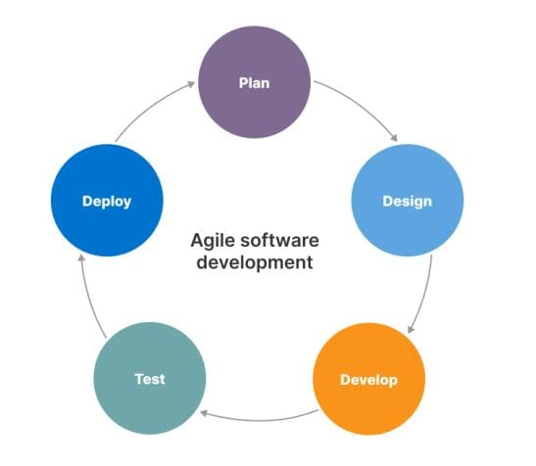 Therefore, the Scrum software development model is recommended for the development of the "Heal Naturally" website.

**12**

**DATA FLOW DIAGRAM (DFD)**

Data flow Diagram is a graphical representation of flow of data in an information system. It uses defined symbols like Rectangle, Circle and Arrows, plus short text Labels to show input outputs, storage points.

There are 3 Type of DFDs:

* 0th Level DFD
* 1st Level DFD
* 2nd Level DFD

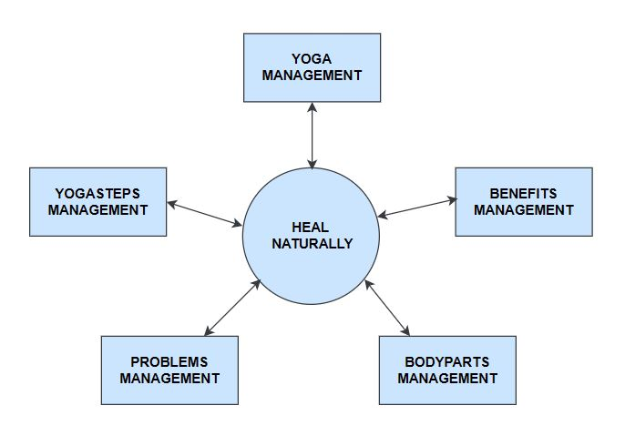**0th Level DFD**

**13**

**1st Level DFD**

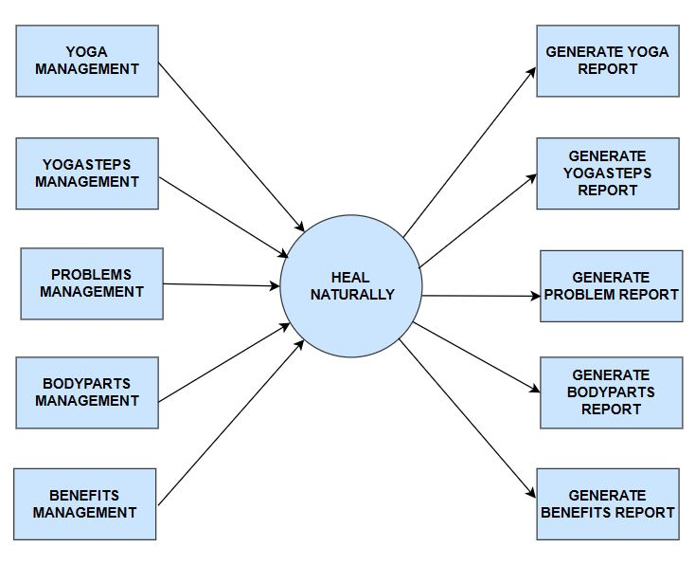

**14**

**2nd Level DFD**

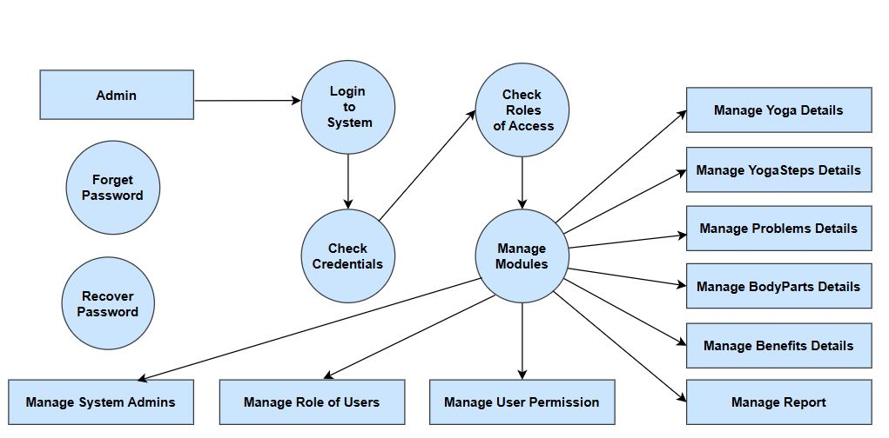

**15**

**ENTITY RELATIONSHIP DIAGRAM (ERD)**

Entity Relationship Diagram (ERD) is a visual representation of different entities within a system and how they relate to each other. Entity relationship diagrams are used in software engineering during the planning stages of the software project. They help to identify different system elements and their relationships with each other.

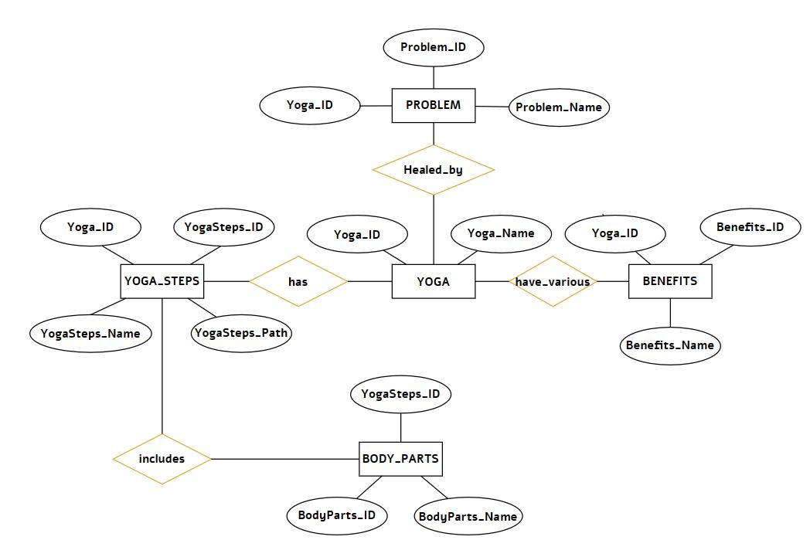

**16**

**FLOW CHART**

A flowchart is a diagram that depicts a process, system or computer algorithm. They are widely used in multiple fields to document, study, plan, improve and communicate often complex processes in clear, easyto-understand diagrams. Flowcharts, sometimes spelled as flow charts, use rectangles, ovals, diamonds and potentially numerous other shapes to define the type of step, along with connecting arrows to define flow and sequence.

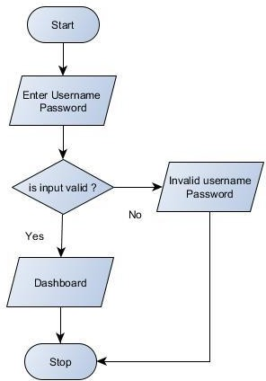

**17**

**SYSTEM DESIGN**

System design is the process of defining the architecture, components, modules, interfaces, and data for a system to satisfy specified requirements. It involves creating a plan and blueprint for how different parts of a system will work together to achieve the desired functionality, scalability, performance, and reliability. System design is essential for building complex software or hardware systems, ensuring they meet the needs of users and stakeholders while being maintainable and adaptable to future changes.

**INPUT TO THE PROJECT**

In Input of the Project Section it contain overall database elements.

* **Input for New Registration**
* Registration _ID(A/N)
* UserName
* Password
* Confirm_Password
* **Input for Login**
* LoginID(A/N)
* UserName
* Password
* **Input for Problem Information**
* ProblemID(A/N)
* ProblemName
* ProblemImagePath
* CausesPath

**18**

* **Input for Yoga**
* YogaID(A/N)
* YogaName
* **Input for ProblemDetailsYoga**
* ProblemDetailYogaID(A/N)
* ProblemID
* YogaID
* **Input for YogaSteps**
* YogaStepsID(A/N)
* YogaStepsName
* YogaStepsImagePath
* YogaID
* **Input for BodyParts**
* BodyPartsID(A/N)
* BodyPartsName
* **Input for BodyPartsUsed**
* BodyPartsUsedID(A/N)
* YogaID
* BodyPartsID
* **Input for BenefitsID**
* BenefitsID(A/N)
* BenefitsName
* YogaID

**19**

**OUTPUT OF THE PROJECT**

The Project Heal Naturally is made to get Solution of your Problem Naturally by Adapting some yoga practices in your routine.

1. Search For Your Problem.
2. Select your Problem.
3. Know Causes of Your Problem.
4. Recommend Yoga Poses According to your Problem.
5. Know Benefits of Particular Yoga.
6. See how that yoga Pose is Practiced by involving which body Part.

**20**

**MODULARIZATION DETAILS**

Modularization for the "Heal Naturally" project involves breaking down the system into smaller, manageable modules or components. This approach enhances maintainability, scalability, and reusability while promoting better organization and collaboration among developers. Here's how modularization can be applied to the project:

**USER INTERFACE MODULE**

This module would handle all aspects of the user interface, including navigation, layout, and interaction. It would consist of various sub-modules for different sections of the website or application, such as the homepage, yoga routines, community forums, and user profiles.

**YOGA ROUTINE MODULE**

This module would manage the creation, storage, and retrieval of personalized yoga routines for users. It would include functionalities for selecting yoga poses, creating custom routines, tracking progress, and providing recommendations based on user preferences and health conditions.

**MANAGEMENT MODULE**

This module would handle the management and delivery of content related to yoga, health, wellness, and mindfulness. It would include functionalities for creating, editing, organizing, and categorizing.

\\\

**21**

**USER AUTHENTICATION AND AUTHORIZATION MODULE**

This module would handle user authentication, registration, and authorization processes to ensure secure access to the platform. It would include functionalities for user account management, password reset, email verification, and role-based access control.

**DATA MANAGEMENT MODULE**

This module would manage the storage and retrieval of data within the system, including user profiles, yoga routines, community interactions, and content. It would interact with the database or data storage layer to perform CRUD (Create, Read, Update, Delete) operations and ensure data integrity and consistency.

**INTEGRATION MODULE**

This module would handle integration with external databases, or services to access additional resources such as yoga routines, health data, meditation guides. It would include functionalities for data synchronization, error handling, and communication.

**ADMINISTRATIVE MODULE**

This module would provide administrative tools and dashboards for managing user accounts, content, community interactions, and system settings. It would include functionalities for user moderation, content moderation, analytics, reporting, and system configuration.

By modularizing the "Heal Naturally" project, can work on individual components independently, making it easier to maintain, scale, and evolve the system over time. Each module can be developed, tested, and deployed separately, promoting better code organization, reuse, and collaboration among team members. Additionally, modularization allows for easier integration of new features, technologies, and third-party services as the project grows.

**22**

**CLASS DIAGRAM**

A class diagram is a type of static structure diagram in the Unified Modeling Language (UML) that represents the structure and relationships of classes within a software system. It provides a visual representation of the classes, attributes, methods, and associations present in the system, helping to visualize the system's architecture and design.

Here's an explanation of the key components of a class diagram:

**1. Class:** A class represents a blueprint or template for creating objects in the system.

**2. Attributes:** Attributes represent the data or state of a class. Attributes are typically depicted as name-value pairs within the class rectangle

**3. Methods:** Methods represent the behavior or operations that objects belonging to the class can perform. Methods are depicted within the class rectangle and include the method name, parameters (if any), and return type (if applicable).

**4. Associations:** Associations represent relationships between classes. They describe how classes are connected or interact with each other. Associations are depicted as lines connecting two classes, with optional arrows indicating the direction of the relationship.

**5. Inheritance:** Inheritance represents the "is-a" relationship between classes, where one class (subclass or child class) inherits attributes and methods from another class (superclass or parent class).

**23**

**6. Composition and Aggregation:** Composition and aggregation represent the "has-a" relationship between classes, where one class contains or is composed of other classes.

Class diagrams serve as an essential tool for visualizing and communicating the design of a software system, enabling developers to understand the structure, dependencies, and interactions between classes effectively. They provide a high-level overview of the system's architecture and facilitate the analysis, design, and implementation of complex software systems.

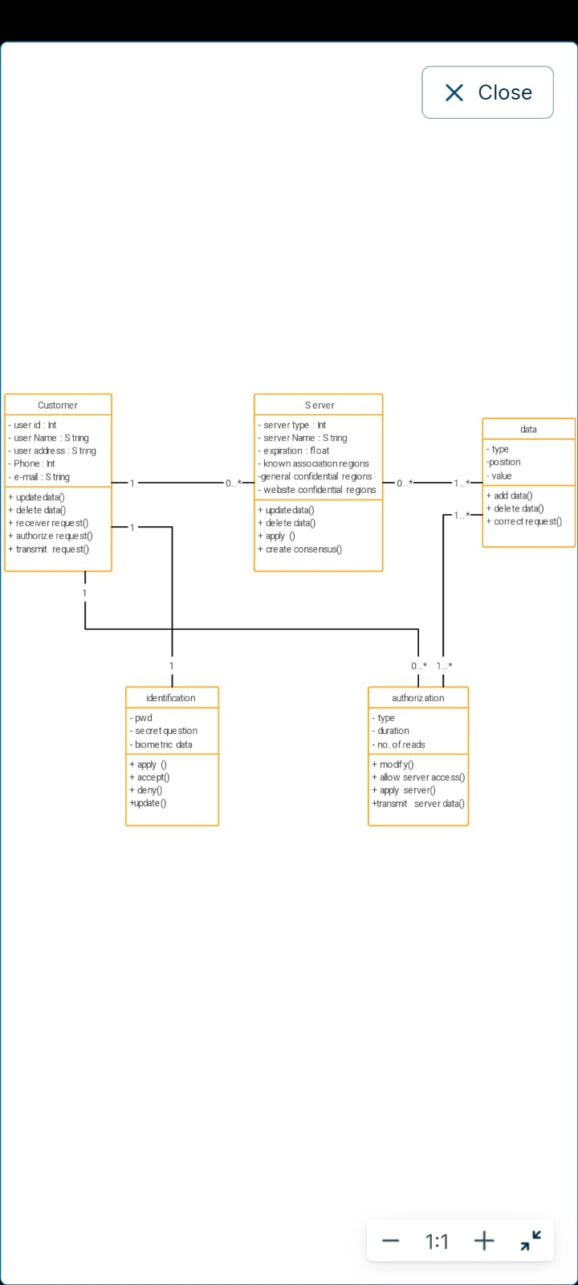

**24**

**PROCESS LOGIC:**



User Login

User_Panel

Profile

Submit Request

Service Status

Change Password

Logout

Update

Submit

Search

Update

Delete

**25**

**25**

**DATA INTEGRITY**

Data integrity refers to the accuracy, consistency, and reliability of data stored within a system or database. It ensures that the data remains unchanged and retains its intended meaning and validity throughout its lifecycle. Data integrity is maintained through various mechanisms, including data validation, error checking, encryption, access controls, and backup and recovery procedures.

In simpler terms, data integrity ensures that the data you store in a system remains accurate, consistent, and reliable, without being corrupted or compromised. It is essential for maintaining the trustworthiness and usability of data for decision-making, analysis, and operations within an organization.

Data integrity for the "Heal Naturally" project refers to ensuring that the data stored within the system is accurate, consistent, and reliable throughout its lifecycle. This includes preventing unauthorized access, maintaining data accuracy, and enforcing constraints to preserve data consistency. In short, data integrity ensures that the information used by users, administrators, and other stakeholders remains trustworthy and valid, supporting the platform's functionality and user experience.

**26**

**DATA DICTIONARY**

In the context of the "Heal Naturally" project, a data dictionary is a centralized repository or document that provides a comprehensive overview of the data elements used within the system. It includes descriptions of each data element, such as its name, data type, format, meaning, and usage within the system. The data dictionary serves as a reference guide for developers, database administrators, and other stakeholders, ensuring consistency, clarity, and understanding of the data structure and semantics within the project.

**Table Name : tblRegister**

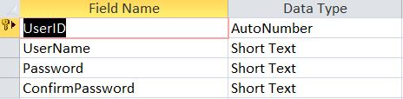

**Table Name : tblProblem**

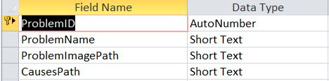

**Table Name : tblYoga**

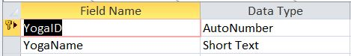

**27**

**Table Name : tblProblemDetails**

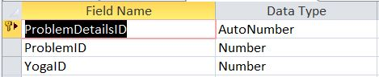

**Table Name : tblYogaSteps**

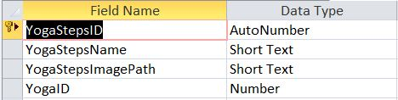

**Table Name : tblBodyParts**

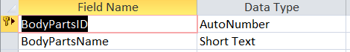

**Table Name : tblBodyPartsUsed**

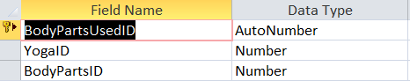

**Table Name : tblBenefits**

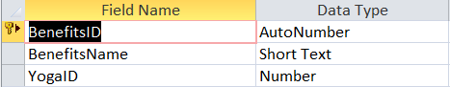

**28**

**TOOLS AND ENVIRONMENT**

|  |  |
| --- | --- |
| Processor | i5 Processor |
| Ram | 1.2 GB |
| Disk Space | 3.5 Available Hard Disk |
| Diplay | 1920 X 1080 |
| Environmet | JDK |

SOFTWARE REQUIREMENTS

|  |  |
| --- | --- |
| Operating System | Windows 11 |
| Front End | Advance Java |
| Back End | Core Java |
| Text Editor | TextPad |
| Database | Access |

**29**

**SOFTWARE DESCRIPTION**

**TEXTPAD**

TextPad is a text editor for Microsoft Windows developed by Helios Software Solutions. It is currently in its eighth major version.TextPad was initially released in 1992 as shareware, with users requested to pay a registration fee to support future development. As of 1996 the company was an associate member of the Association of Shareware Professionals.

**Why JAVA?**

Java is a high-level, object-oriented programming language developed by Sun Microsystems (now owned by Oracle). It's known for its platform independence, meaning Java programs can run on any device that has a Java Virtual Machine (JVM). Java is widely used for building web applications, mobile apps (Android), desktop applications, and enterprise software.

**30**

**PROJECT UI**

**FrmFrontPage.java**

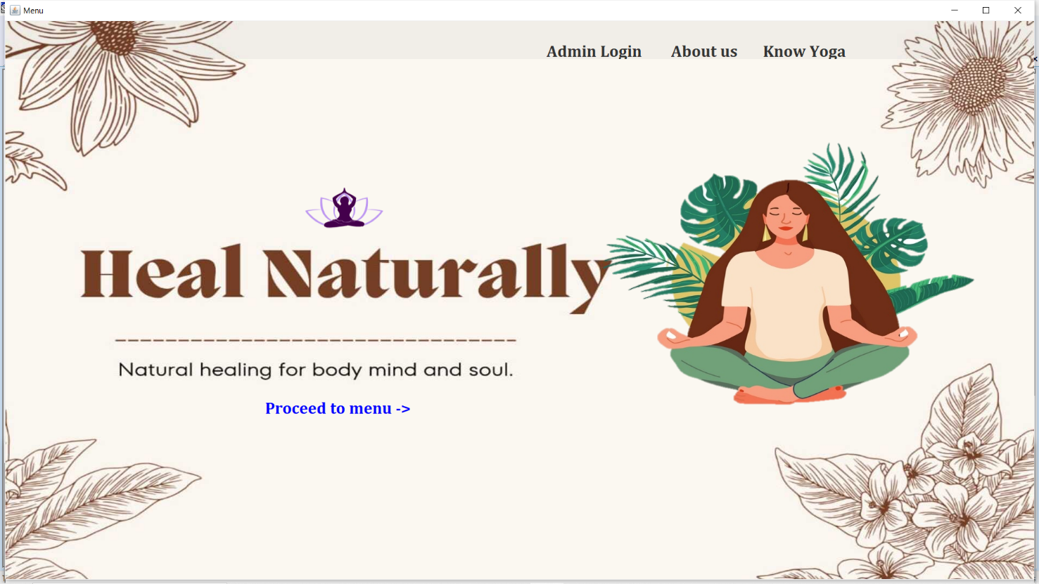

**FrmRegistration.java**



**31**

**FrmLogin.java**

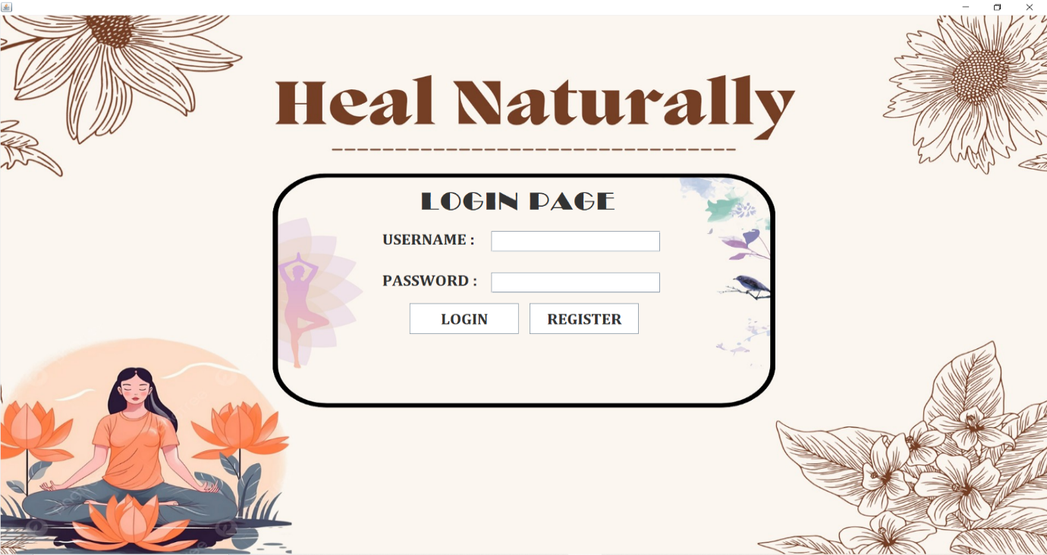

**RPTProblemPortal.java**

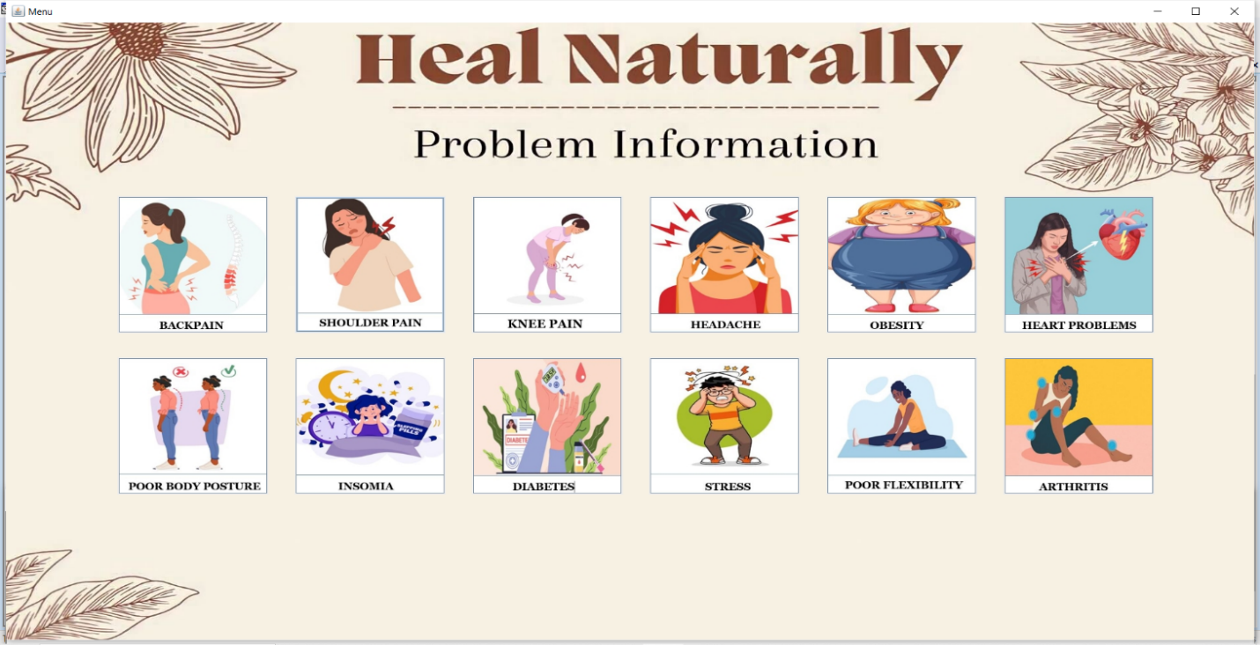

**32**

**FrmProbleminfo.java**

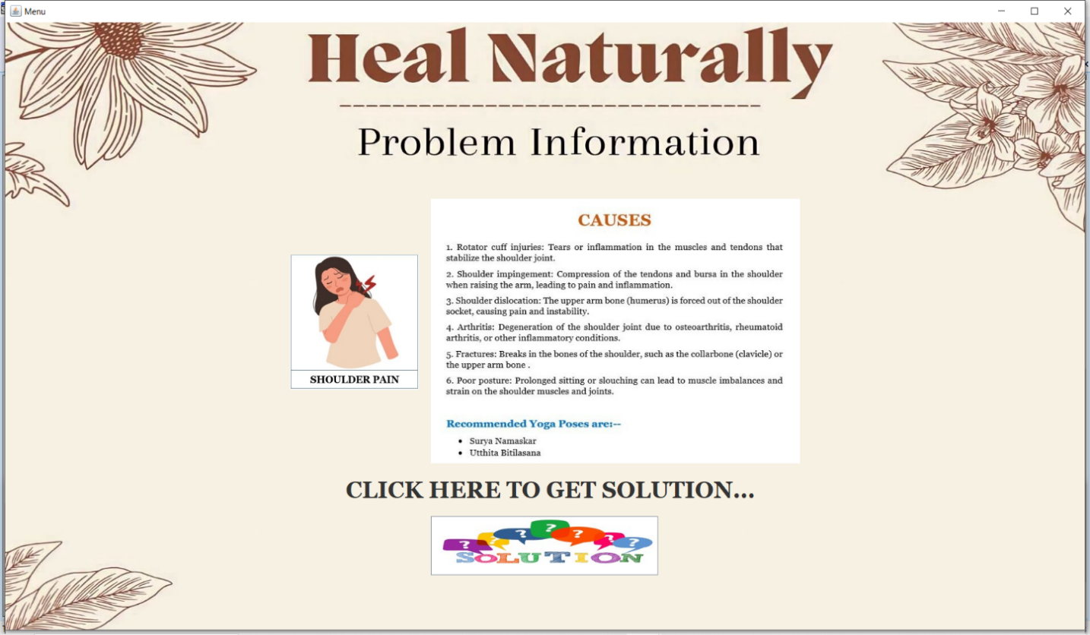

**RPTYogaExplorer.java**

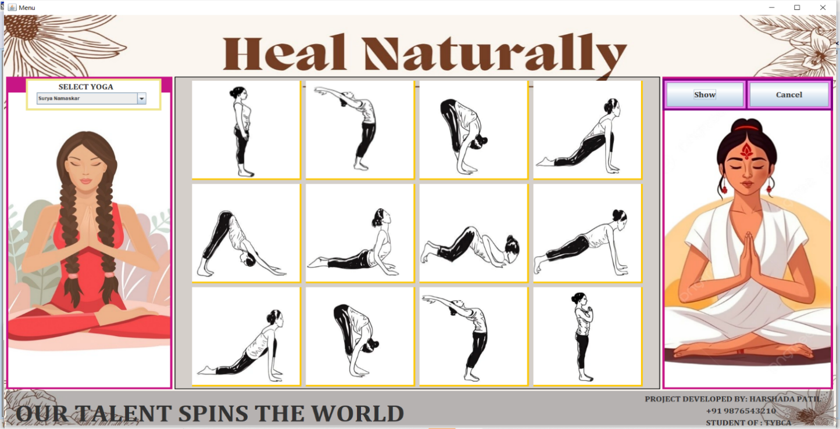

**33**

**RPTYogaBenefits.java**

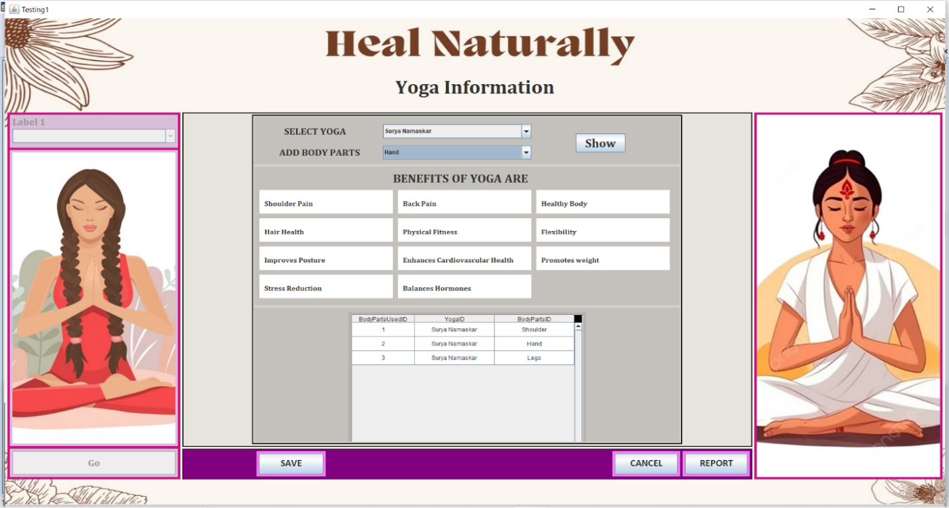

**FrmKnowYoga.java**

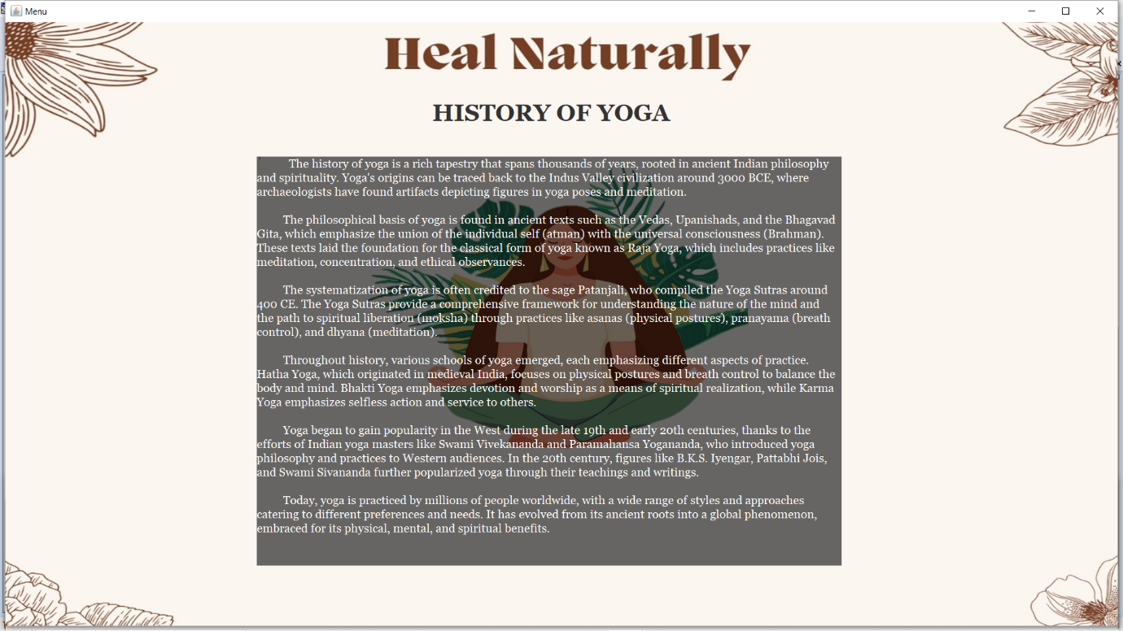

**34**

**FrmAdminLogin.java**

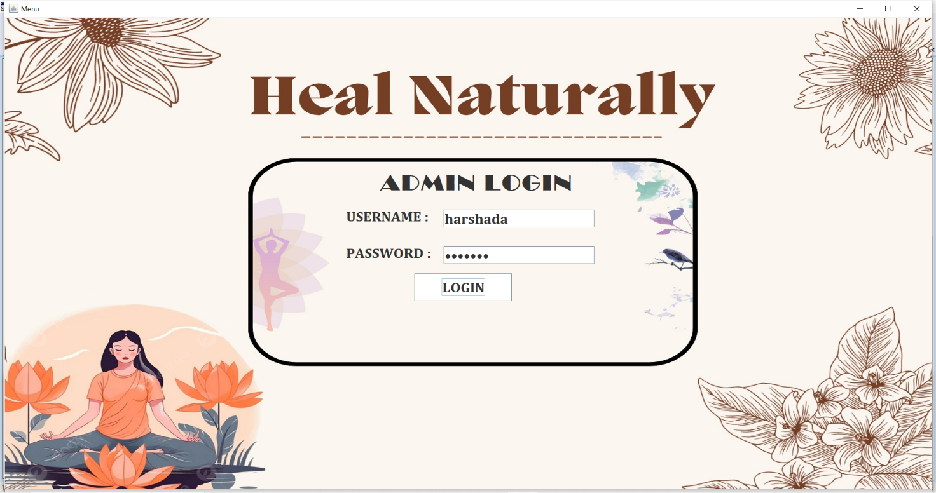

**FrmAdminMenu.java**

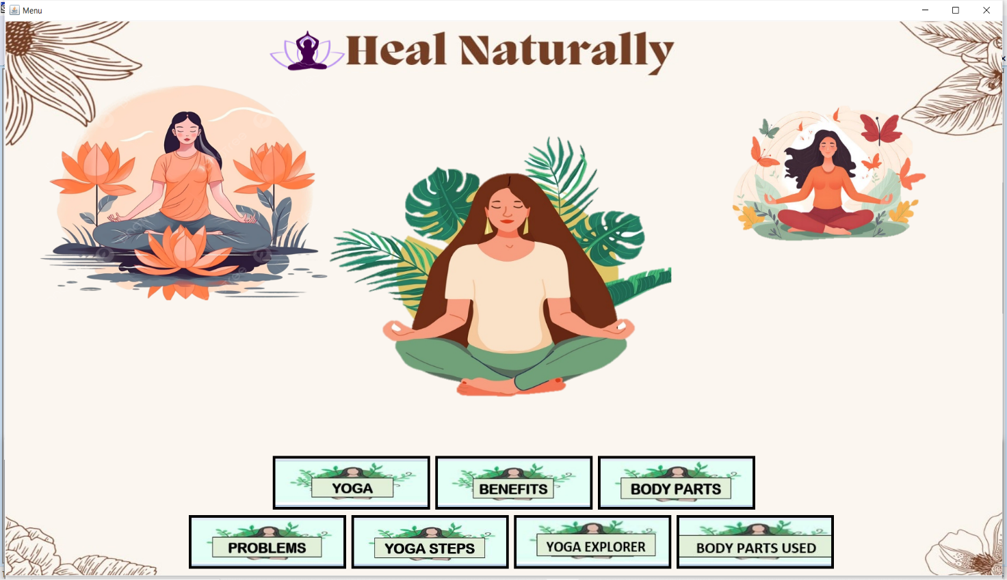

**35**

**FrmYoga.java**

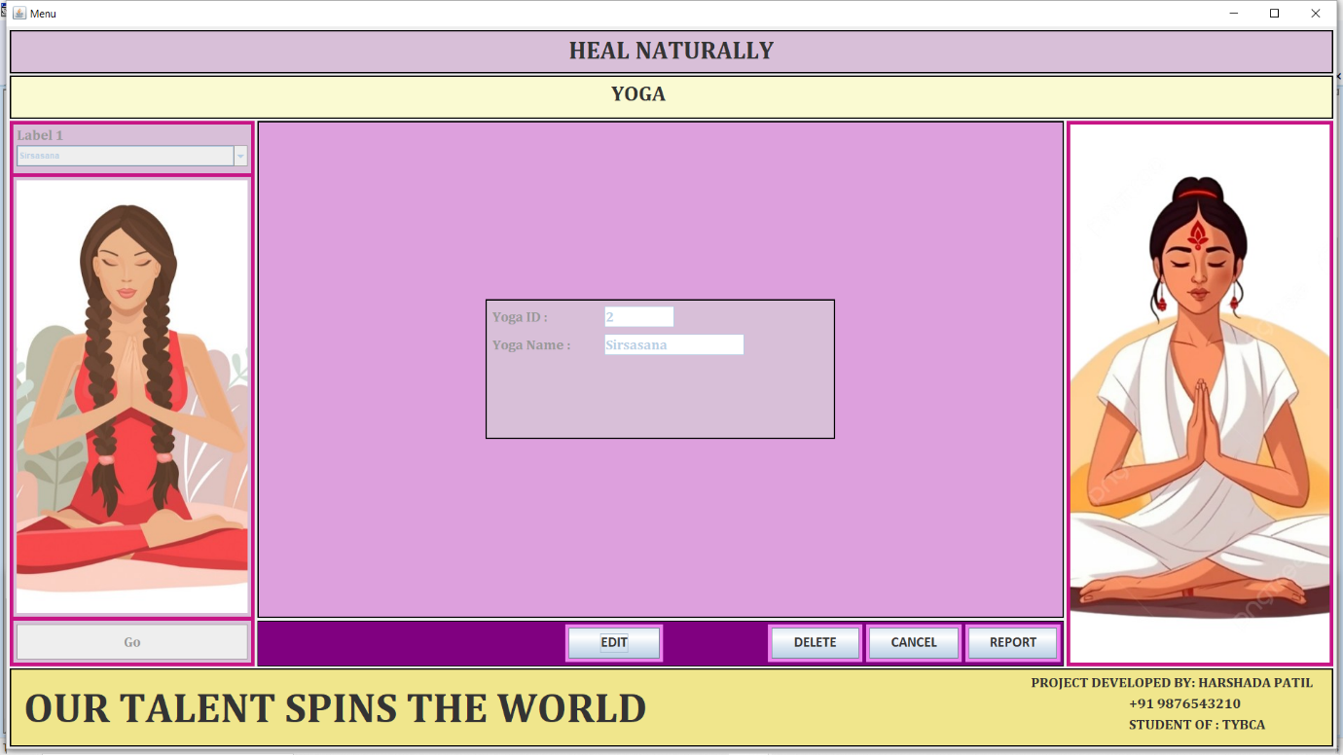

**RPTYoga.java**

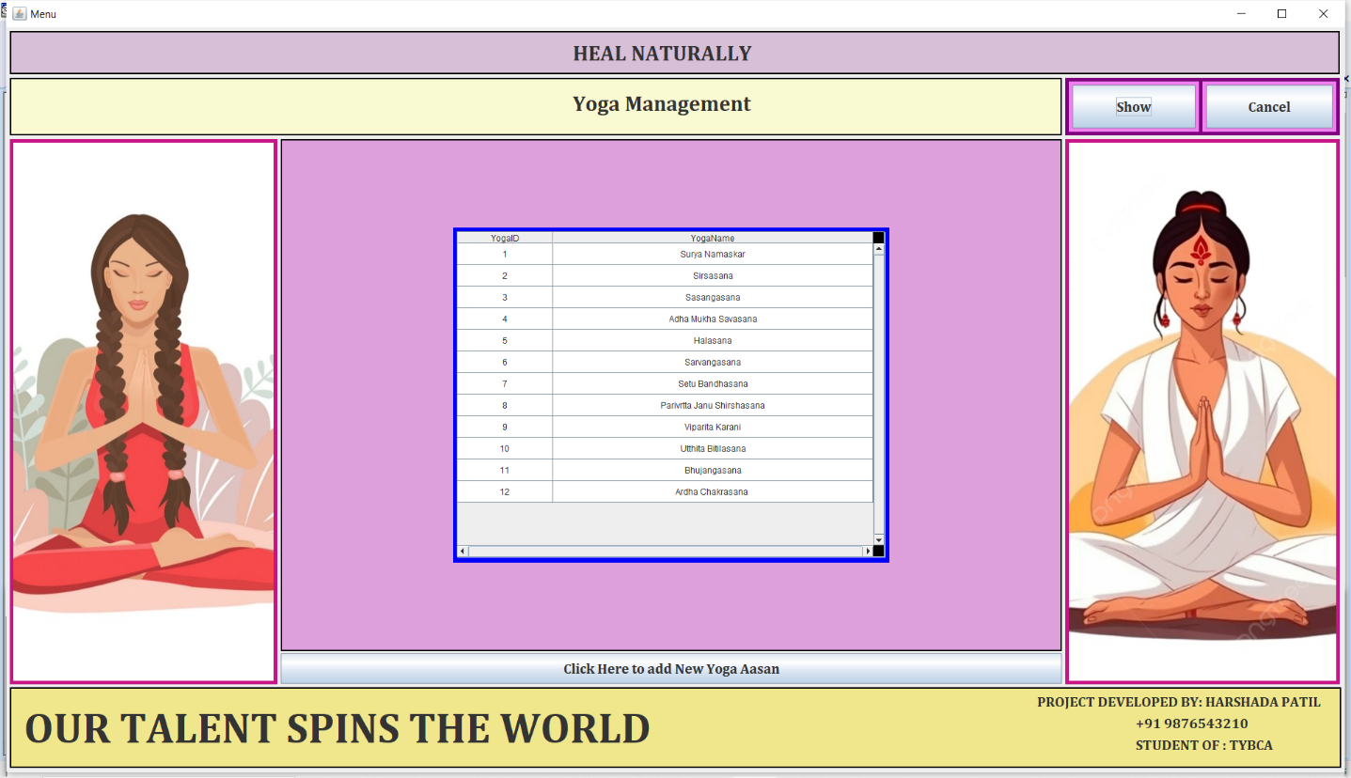

**36**

**FrmBenefits.java**

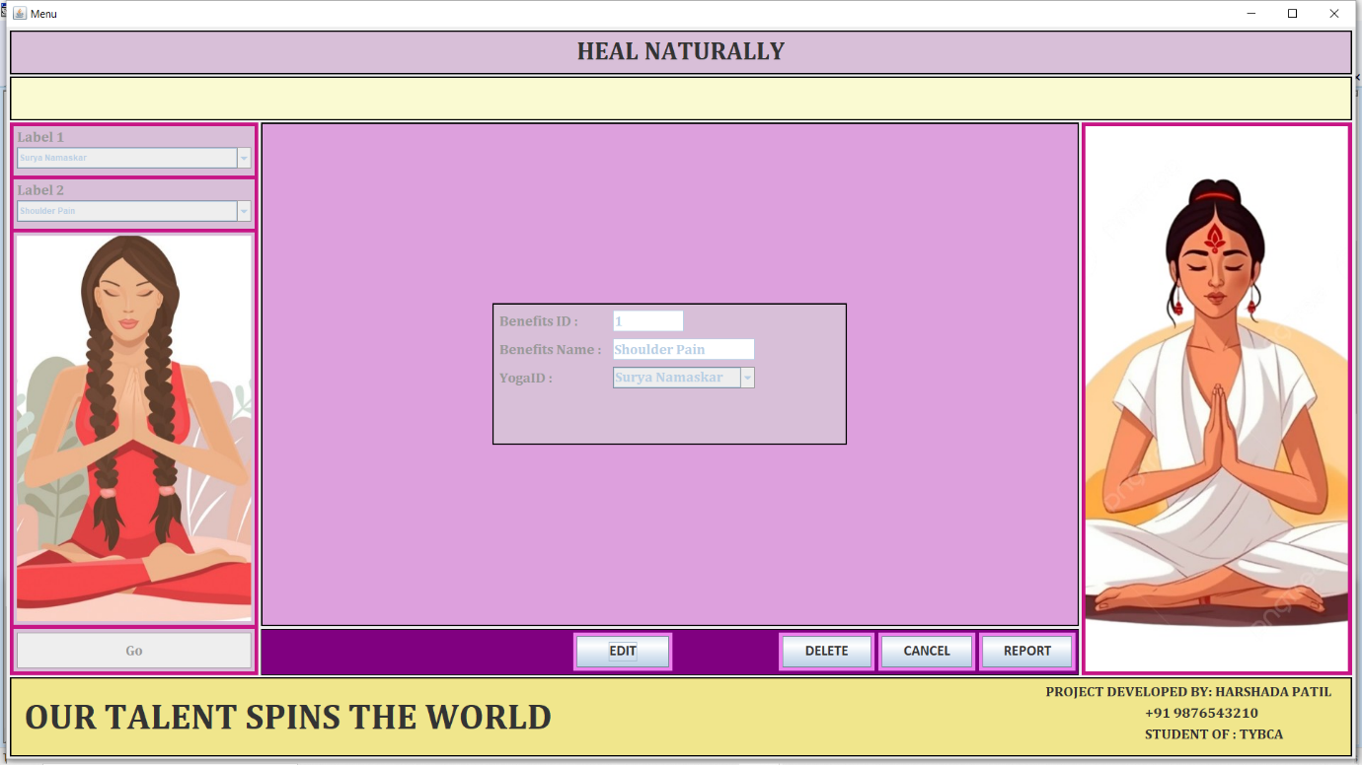

**RPTBenefits.java**

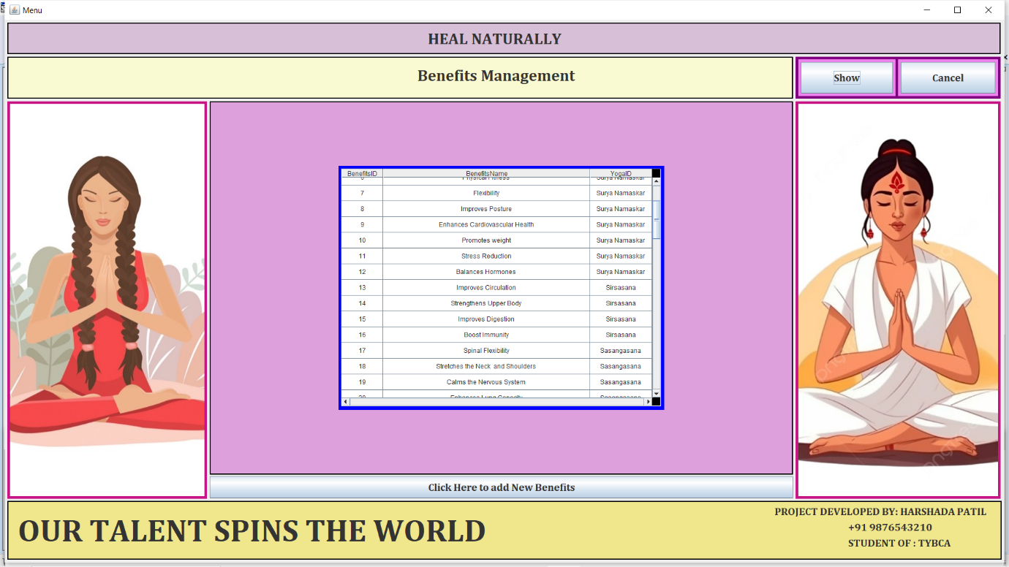

**37**

**TESTING**

Software testing is a systematic process of evaluating a software application or system to identify defects, errors, or discrepancies between expected and actual behavior . It involves executing the software under controlled conditions to verify its functionality, performance, security, and usability. The primary goal of testing is to ensure that the software meets specified requirements and delivers a satisfactory user experience.

Testing for the "Heal Naturally" project implemented in advanced Java is crucial to ensure the reliability, functionality, and usability of the platform. Here's an overview of testing aspects for the project:

**1. Unit Testing:** Unit testing involves testing individual components or units of code in isolation to verify that they function correctly. In the context of the project, unit tests would be written to test methods, functions, and classes responsible for specific functionalities such as user authentication, yoga routine generation, community interaction, and data management.

**2. Integration Testing:** Integration testing focuses on verifying the interactions and interoperability between different components or modules of the system. It ensures that individual units work together as expected and that data flows correctly between them. Integration tests for the "Heal Naturally" project would validate interactions between user interface components, backend services, databases, and external APIs.

**3. User Interface Testing:** User interface testing involves evaluating the usability, accessibility, and functionality of the platform's graphical user interface (GUI). This includes testing navigation, layout, input validation, error handling, responsiveness, and compatibility across different devices and screen sizes. Automated testing tools or frameworks such as Selenium or Appium could be used for UI testing.

**38**

**4. Performance Testing:** Performance testing assesses the responsiveness, scalability, and stability of the platform under various load conditions. It ensures that the system can handle expected user traffic and data volumes without degradation in performance. Performance tests for the "Heal Naturally" project would measure response times, throughput, resource utilization, and system stability under normal and peak usage scenarios.

**5. Security Testing:** Security testing identifies vulnerabilities and weaknesses in the platform's security measures and ensures that sensitive data remains protected from unauthorized access or attacks. This includes testing for authentication mechanisms, authorization controls, data encryption, input validation, and compliance with security standards such as OWASP Top 10.

**6. User Acceptance Testing (UAT):** User acceptance testing involves validating the system's functionality and usability from the perspective of end-users. It ensures that the platform meets user requirements, expectations, and business objectives. UAT for the "Heal Naturally" project would involve engaging real users to perform tasks, provide feedback, and report any issues or concerns.

**7. Regression Testing:** Regression testing ensures that new changes or updates to the platform do not inadvertently introduce defects or regressions in existing functionalities. It involves re-running previously executed tests to verify that existing features continue to work as expected after modifications. Automated testing tools or scripts can help automate regression testing efforts and streamline the testing process.

**39**

By implementing a comprehensive testing strategy encompassing unit testing, integration testing, user interface testing, performance testing, security testing, user acceptance testing, and regression testing, the "Heal Naturally" project can ensure the quality, reliability, and success of the platform, delivering a seamless and satisfying experience for users.

**USE CASE**

A use case diagram is essentially a picture showing system behavior along with the key actors that interact with the system. The use case represents complete functionality. Use case diagram can be imagined as a black box where only the input, output, and the function of the black box are known. Use Case elements are used to make test cases when performing the testing. The use case should contain all system activities that have significance to the users. A use case can be thought of as a collection of possible scenarios related to a particular goal, indeed. Use cases can be employed during several stages of software development, such as planning system requirements, validating design and testing software.

**Use case Diagram Objects**

**Use case diagrams mostly consist of 3 objects: -**

* 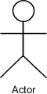**Actor -** Actor is a use case diagram is any entity that performs a role in one given system. This could be a person, organization or an external system.
* 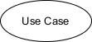**Use Case -** A Use case represents a function or an action within the system. its drawn as an oval and named with the function.

**40**

* **System -** System is used to define the define the scope of the use case and drawn as rectangle.

**There are two functions: -**

* **Include** **–** This represents required. Symbol of this function is dashed arrow and arrow is labeled with the keyword <<include>>.

-------------->

* **Extend –** This represents optional and it is also shown with dashed arrow the arrow is labelled with the keyword<<extended>>.

<---------------

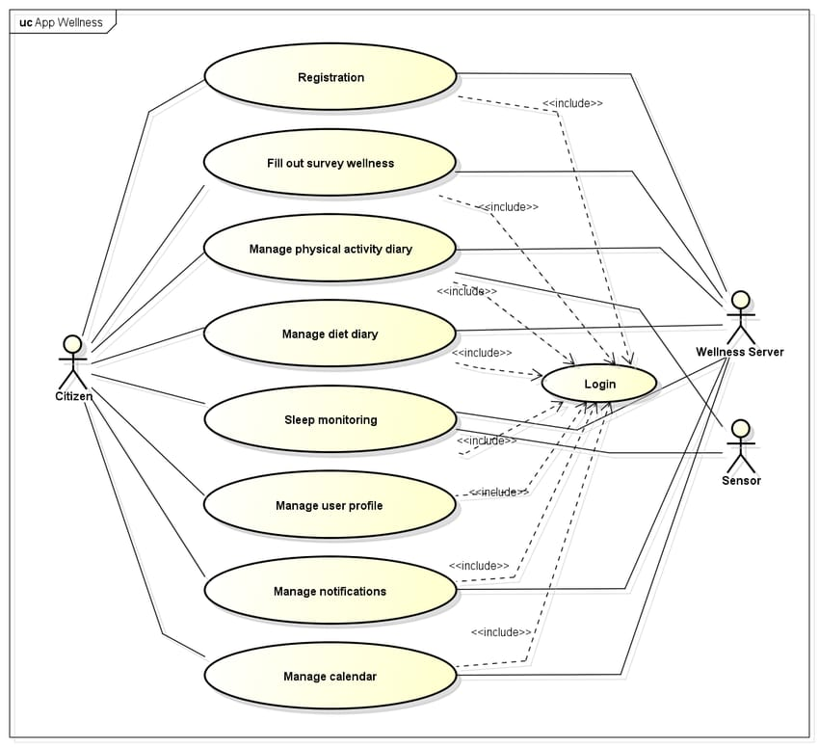

**41**

**IMPLEMENTATION**

Our Dedication to our Client goes well beyond the deployment of our software. We Committed to provide our client with a positive experience that starts with a successful implementation. Implementation is the stage in the project where the theoretical design in turned into working system. The most stage is achieving a new successful system is that it work efficiently and effectively.

**42**

**FUTURE SCOPE**

Heal Naturally can explore several avenues for expansion and enhancement to further enrich the user experience and extend its impact. Some potential future scope areas include:

**ADVANCED PERSONALIZATION**

Implement more sophisticated algorithms and machine learning techniques to enhance the personalization of yoga routines based on user preferences, feedback, and biometric data. This could include adaptive recommendations tailored to users' evolving needs and goals.

**INTEGRATION WITH WEARABLE DEVICES**

Integrate with wearable fitness trackers and health monitoring devices to provide users with real-time feedback and insights into their yoga practice and overall well-being. This could include tracking heart rate, breathing patterns, and movement during yoga sessions to provide personalized guidance and recommendations.

**VIRTUAL REALITY (VR) AND AUGMENTED REALITY (AR)**

Explore the integration of VR and AR technologies to create immersive and interactive yoga experiences. Users could participate in virtual yoga classes, explore scenic locations for meditation, or receive visual cues and feedback to improve their posture and alignment during yoga practice.

**43**

**EXPANDED CONTENT REPOSITORY**

Continuously expand the platform's content repository with new articles, videos, tutorials, and resources on yoga, mindfulness, nutrition, and holistic health. Collaborate with experts, instructors, and wellness practitioners to provide diverse and high-quality content to users.

**44**

**CONCLUSION**

"Heal Naturally" project, offers a comprehensive platform dedicated to promoting holistic health and wellness through the practice of yoga. Through careful analysis, design, and development, the project has successfully created a user-friendly and personalized experience that empowers individuals to enhance their physical, mental, and emotional well-being.

**KEY HIGHLIGHTS OF THE PROJECT INCLUDE:**

**PERSONALIZED YOGA ROUTINES**

Users can access tailored yoga routines based on their preferences, fitness levels, and health conditions, fostering a customized approach to wellness.

**COMMUNITY ENGAGEMENT**

The platform provides a supportive community where users can connect, share experiences, and support each other on their wellness journey, fostering a sense of belonging and camaraderie.

**CONTINUOUS IMPROVEMENT**

The project is committed to continuous improvement, with future scope areas including advanced personalization, integration with wearable devices, virtual reality experiences, and expanded community engagement features.

**45**

By leveraging advanced Java technologies and innovative features, the "Heal Naturally" project aims to empower individuals to take control of their health and well-being naturally, promoting a balanced and fulfilling lifestyle through the transformative power of yoga.

**46**

**REFERENCES**

* [*www.wikipedia.com*](http://www.wikipedia.com)
* [*www.google.com*](http://www.google.com)
* [*www.myAI.com*](http://www.myAI.com)
* *Yoga Book*

**47**